

SEQUENCE DIAGRAM – MODULE 3

**Version1.0**

**Nhan Pham**

**04/04/2020**

**VERSION HISTORY**

|  |  |  |  |  |  |
| --- | --- | --- | --- | --- | --- |
| **Version #** | **Implemented**  **By** | **Revision**  **Date** | **Approved**  **By** | **Approval**  **Date** | **Reason** |
| 1.0 | Nhan Pham | 04/04/2020 |  |  | Create document sequence diagram v1.0 |
|  |  |  |  |  |  |
|  |  |  |  |  |  |
|  |  |  |  |  |  |

Table of Contents

1. Introduction 3

1.1 Goal 3

1.2 Execute team 3

1.2 Reader 3

2. SEQUENCE DIAGRAM 3

**2.1. View business results the week "Employees" app 5**

**2.2. View details of the weekly business results the "Employees" app 6**

**2.3. View business results the week "Team" app 5**

**2.4. View business results the week "Room" app 6**

**2.5. View business results graph "Employees" app 7**

**2.6. Search business results graph "Employees" app 7**

**2.7. View the "Team" business results graph app 8**

**2.8. Search results graph "Team" app 9**

**2.9. View business results graph "Rooms" app 10**

**2.10. Search business results graph "Room" app 10**

**2.11. View compare business results "Employees" 11**

**2.12. Search and compare business results "Employees" app 12**

**2.13. View the business results "Team" app 16**

**2.****14. Search and compare business results "Team" app 12**

**2.15. View compare business results "Rooms" app 13**

**2.16. Search and compare business results "Rooms" app 13**

**2.17. View statistic – report website 14**

**2.18. Import file website 19**

**2.19. View personal information app 19**

# 

# Introduction

## Goal

The goal of this document is to design the Sequence Diagram for BDS project

## **Execute team**

|  |  |
| --- | --- |
| **Full name** | **Role** |
| Huỳnh Tuấn Đạt | Leader |
| Trịnh Thị Như Phương | Member |
| Nguyễn Anh Minh | Member |
| Trương Quang Vương | Member |
| Phạm Quốc Nhân | Member |

## **Reader**

|  |  |
| --- | --- |
| **Reader** | **Content** |
| Đặng Đình Hòa | 1, 2, 3 |
| Team | 1, 2, 3 |

# Sequence Diagram

**2.1. View business results the week "Employees" app**

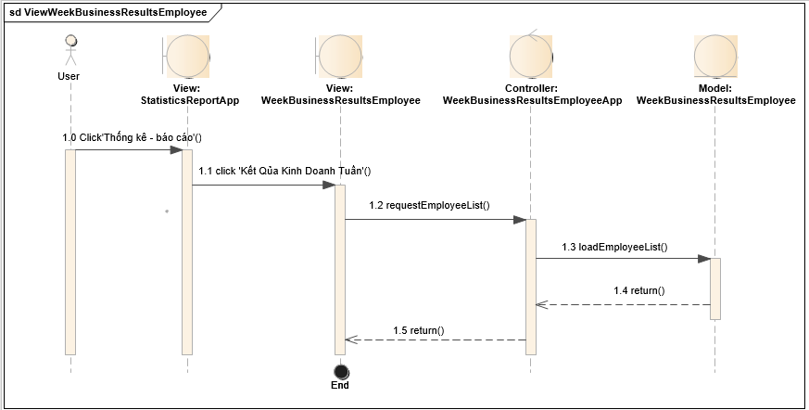

**2.2. View details of the weekly business results the "Employees" app**

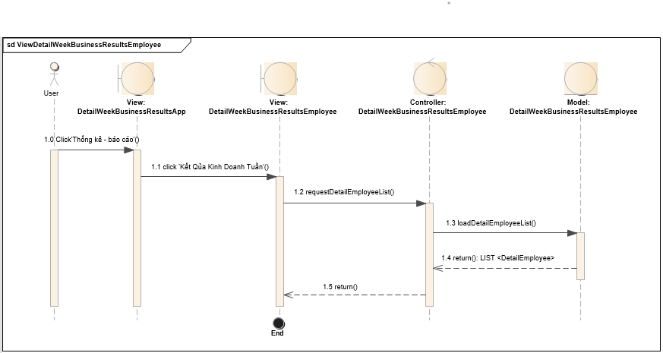

**2.3. View business results the week "Team" app**

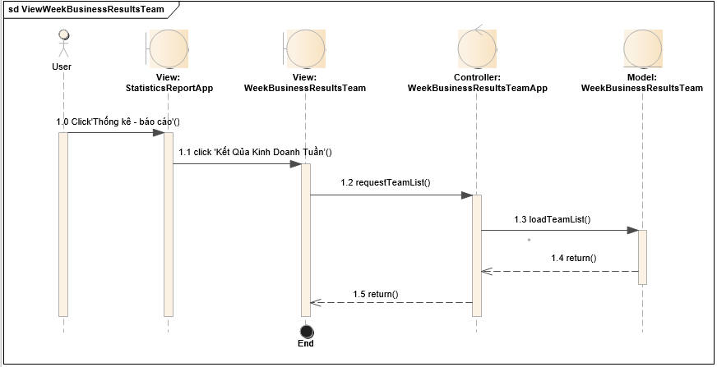

**2.4. View business results the week "Room" app**

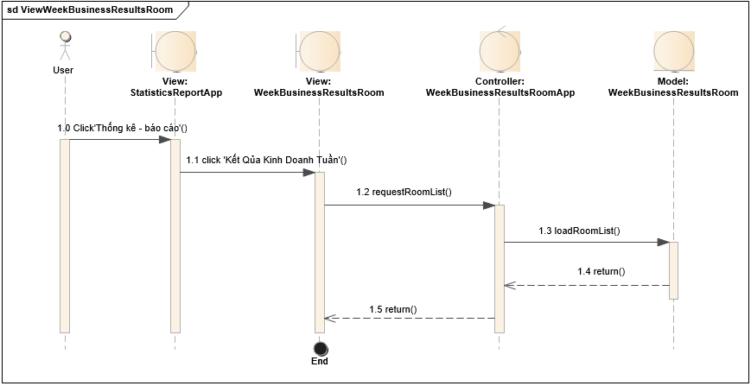

**2.5. View business results graph "Employees" app**

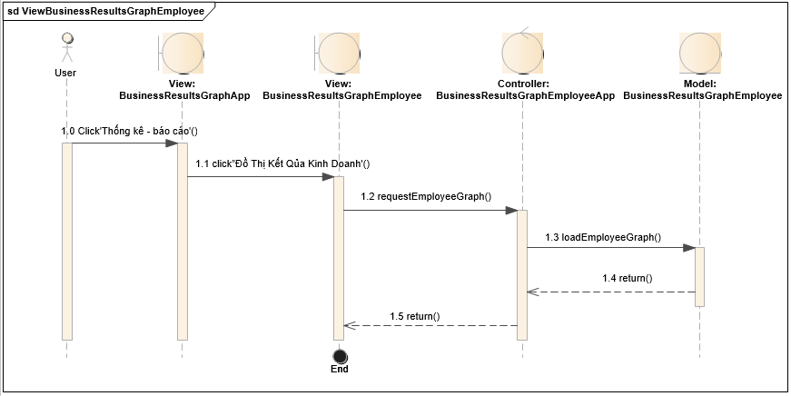

**2.6. Search business results graph "Employees" app**



**2.7. View the "Team" business results graph app**

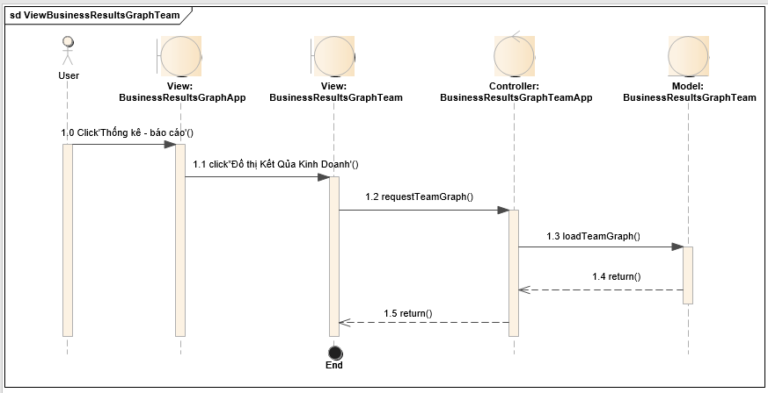

**2.8. Search results graph "Team" app**



**2.9. View business results graph "Rooms" app**

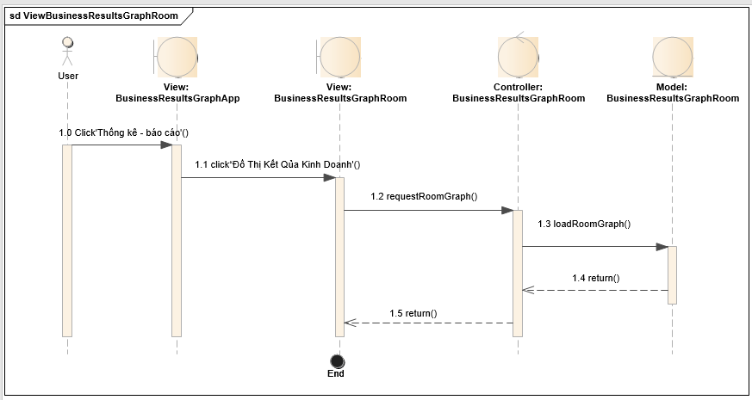

**2.10. Search business results graph "Room" app**



**2.11. View compare business results "Employees"**

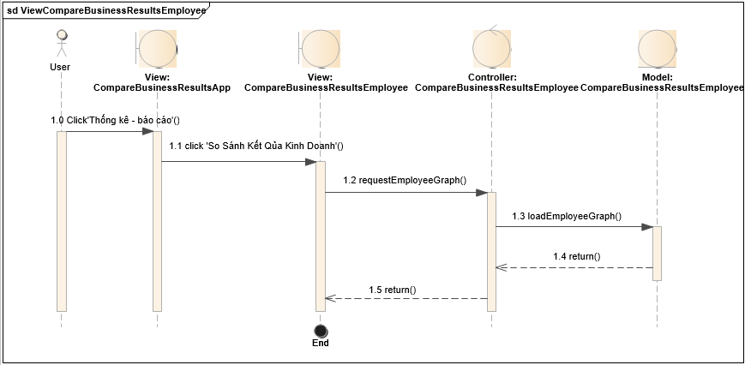

**2.12. Search and compare business results "Employees" app**



**2.13. View the business results "Team" app**

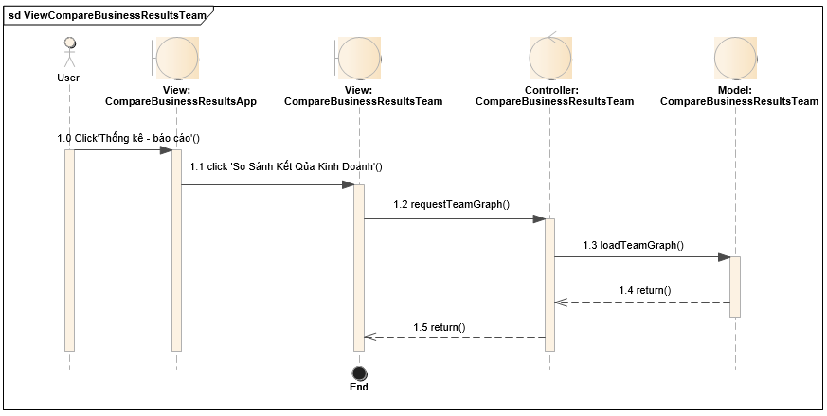

**2.****14. Search and compare business results "Team" app**



**2.15. View compare business results "Rooms" app**

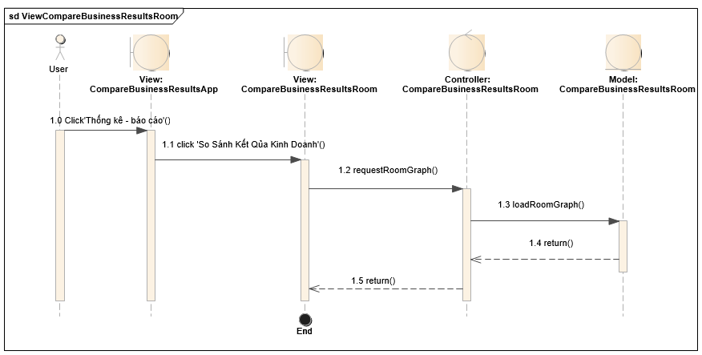

**sd ViewCompareBusinessResultsRoom**

Admin

**View:**

**CompareBusinessResultsApp**

**Controller:**

**CompareBusinessResultsRoom**

**Model:**

**CompareBusinessResultsRoom**

**View:**

**CompareBusinessResultsRoom**

End

End

1.1 click 'So Sánh K?t Q?a Kinh Doanh'()

1.0 Click'Th?ng kê - báo cáo'()

1.5 return()

1.4 return()

1.3 loadRoomGraph()

1.2 requestRoomGraph()

**2.16. Search and compare business results "Rooms" app**



**2.17. View statistic – report website**



**2.18. Import file website**



**2.19. View personal information app**

